Dear Families,
Our whole school production of Beveridge Beats 109.9FM: The Homegrown Hour is taking place during the last week of Term Three on Wednesday 16th September. We will have three performances – 10am, 1pm and 6pm. All three performances will be the same and all students are performing in all three shows. Ticket information will be sent out during Term Three.
All students from Foundation through to Year Six are taking part in the production. We kindly ask that families provide costumes for students specific to the song's genre and era. Please see information below so that you and your child/ren can begin to find items over the holidays to help build a costume. If you require further clarification, please contact the office and we will forward your query to the relevant person who will contact you.

Foundation A & H: Home Among the Gum Trees
Costume: Outback outfit, kookaburra, sheep, kangaroo

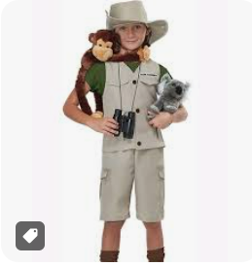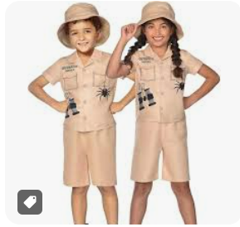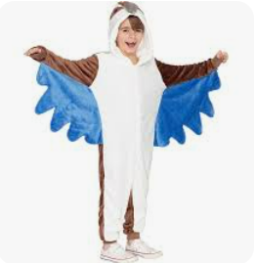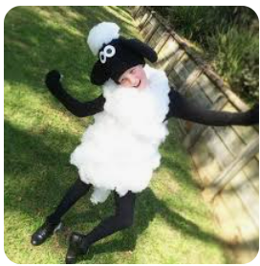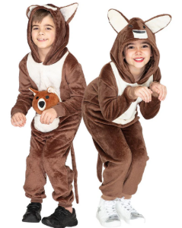

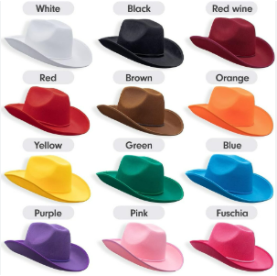
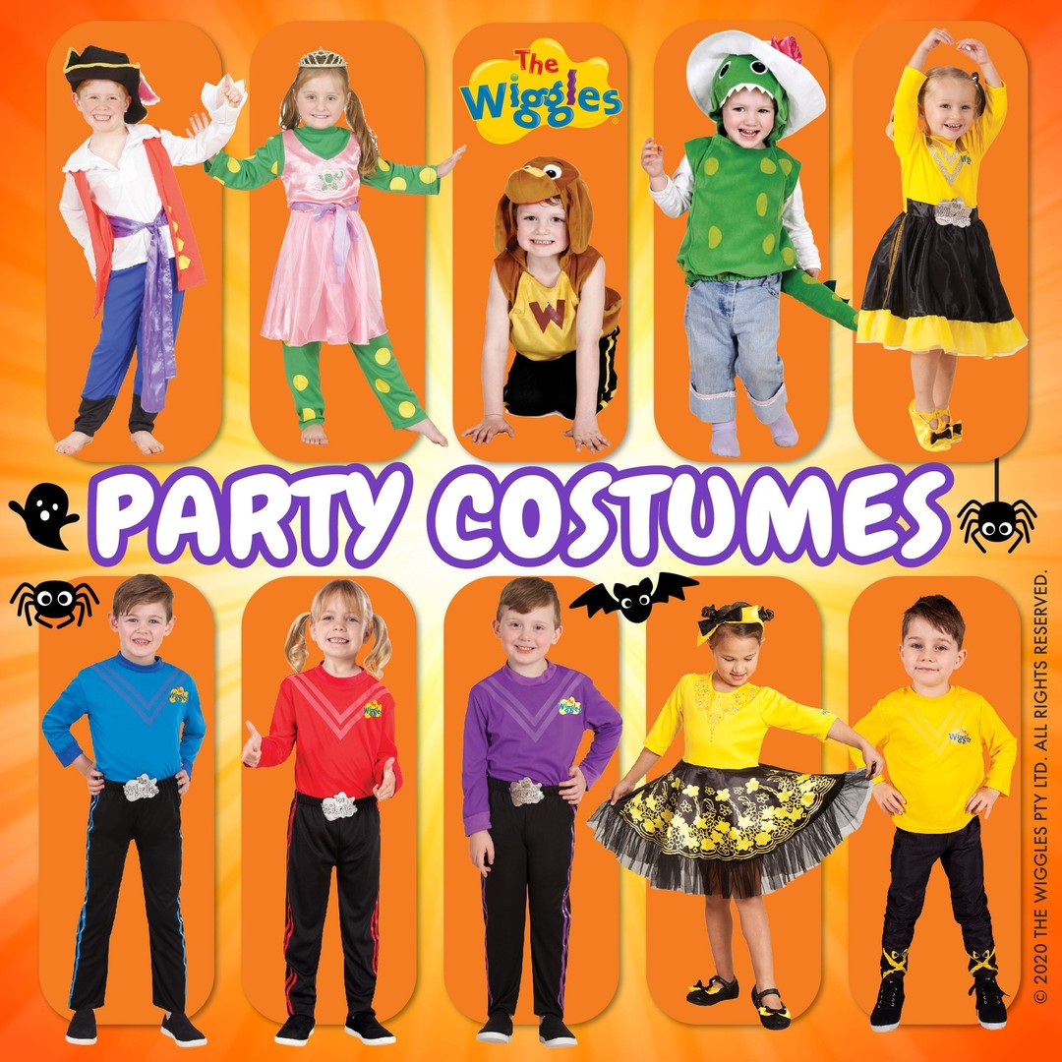
Foundation B, E & F: The Wiggles Medley
Costume: Cowboy boots & hats, Wiggles costumes, or black pants/skirt and a plain yellow/red/blue/purple shirt.
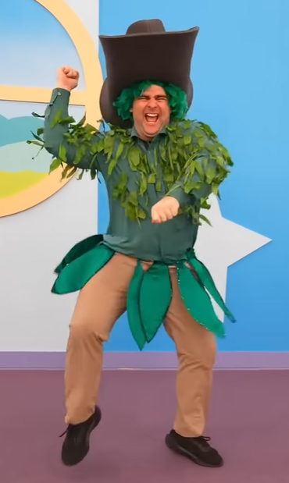
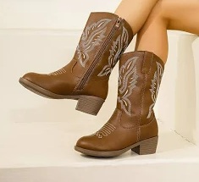

Foundation C, D & G: Ready or Not by Hi-5!
Costume: Colourful and bright clothing/ rainbow colours/ colour block
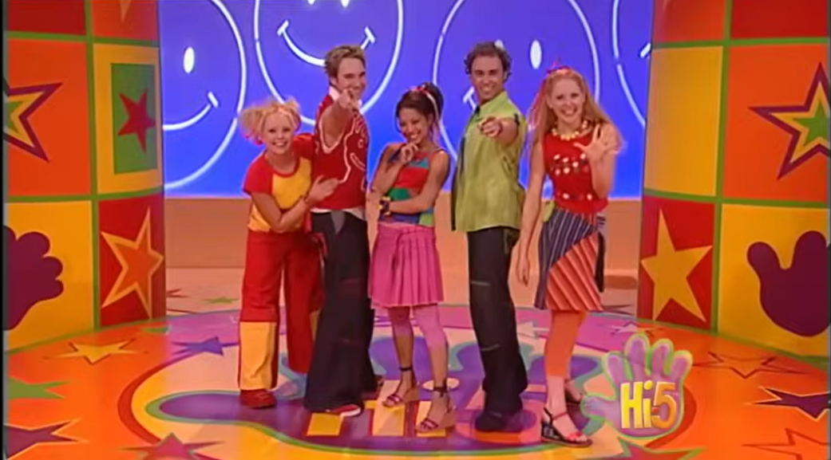

Grade 1 C, D & G: Don’t Worry, be Happy by Guy Sebastian
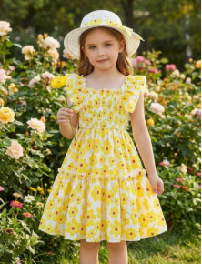
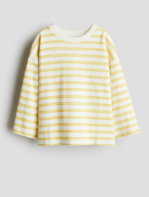
Costume: Blue jeans, plain white or yellow t-shirt, or white and yellow- i.e smiley faces, flowers. ****Optional to wear white and yellow dress****
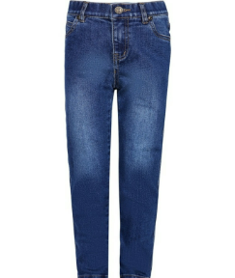
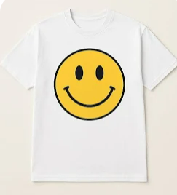

Grades 1A & 1B: Bee Gees - Night Fever - 1977
Costume: 70s Disco
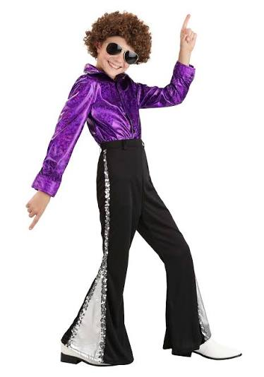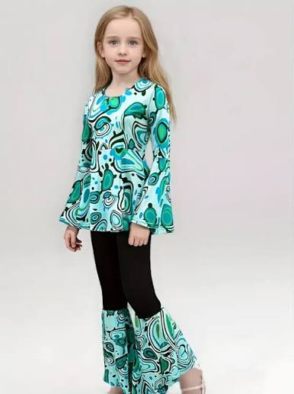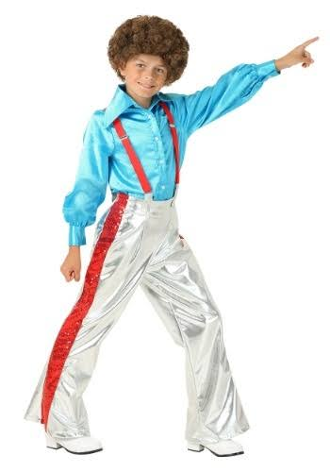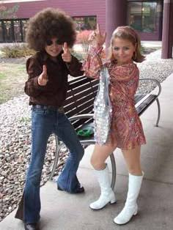

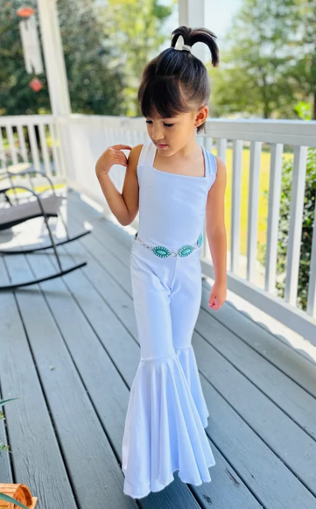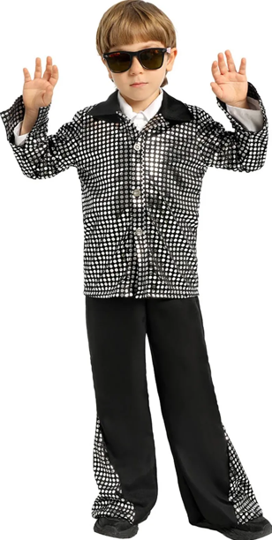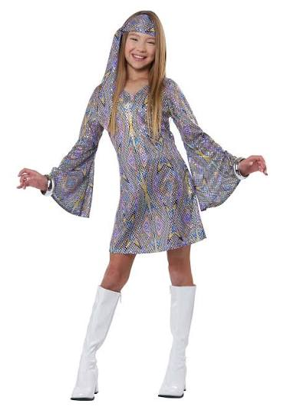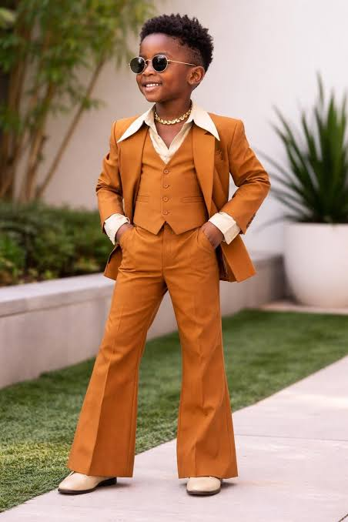
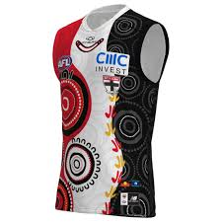
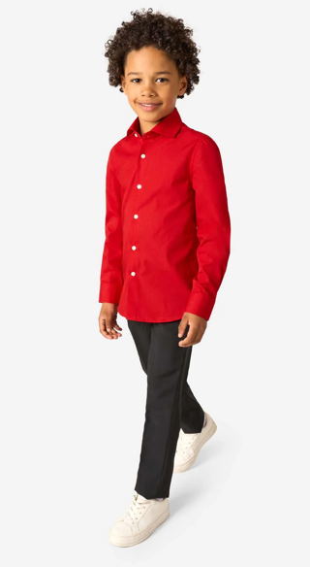
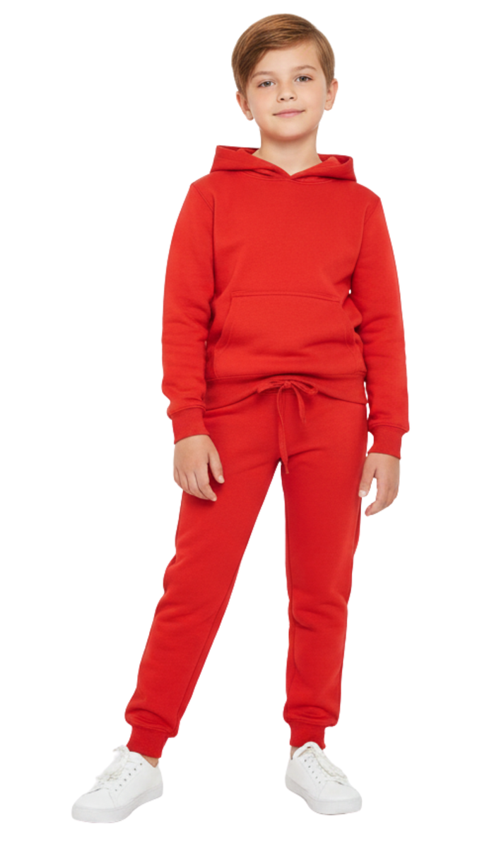
Grades 1E & 1F: Yothu Yindi Treaty - 1990
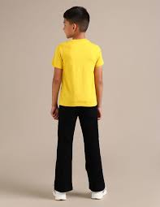
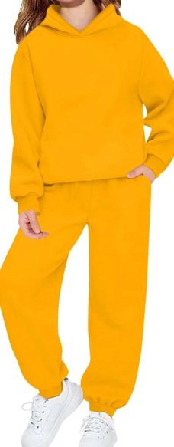
Costume: Australian First Nations colours
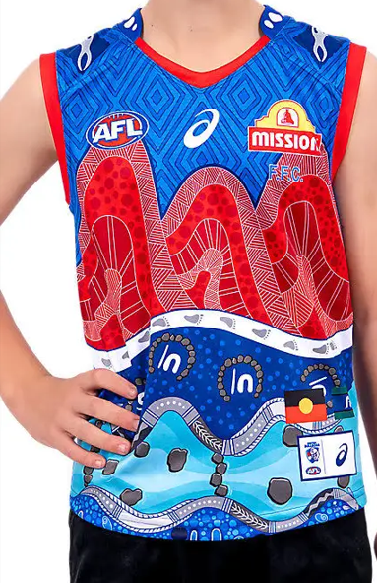
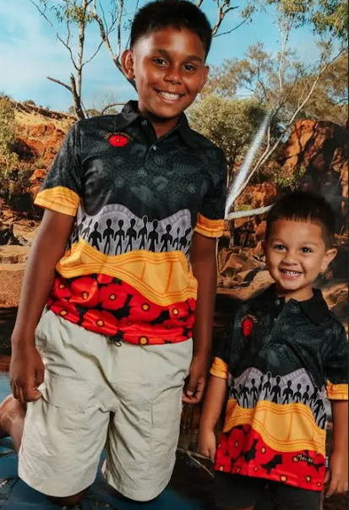
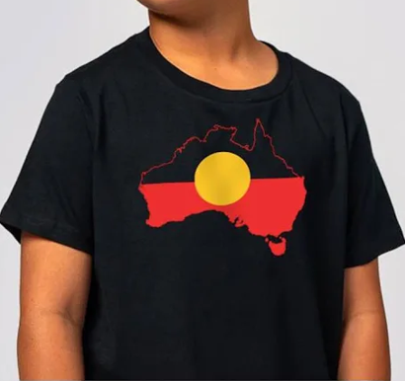
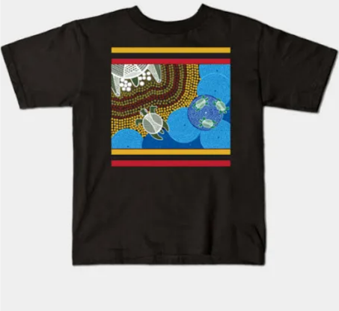

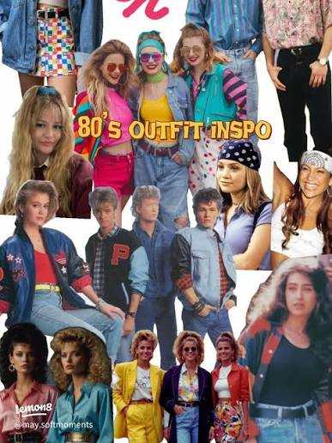
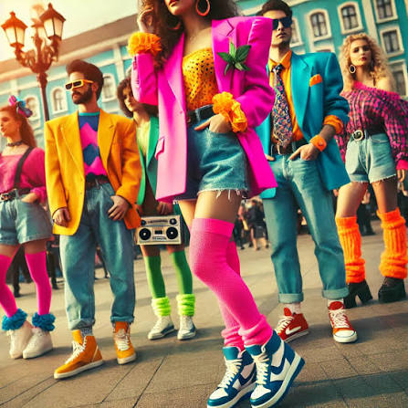
Grades 2A, 2C & 2E: Pseudo Echo – Funky Town - 1985
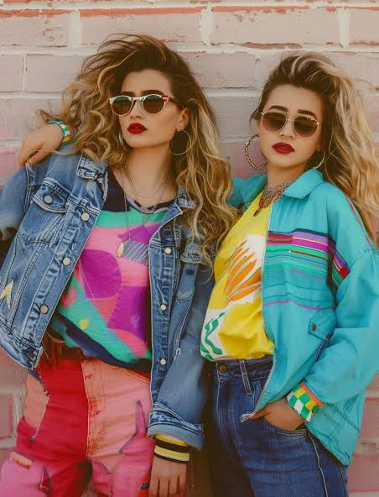
Costume: Classic 80s

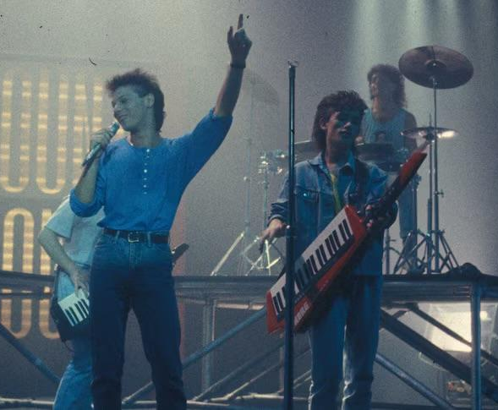
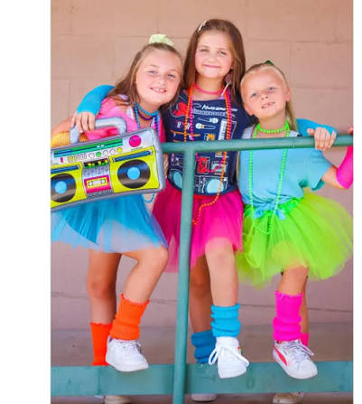

Grades 2B, 2D & 2F: Christine Anu – My Island Home
Costume: Anything Blue
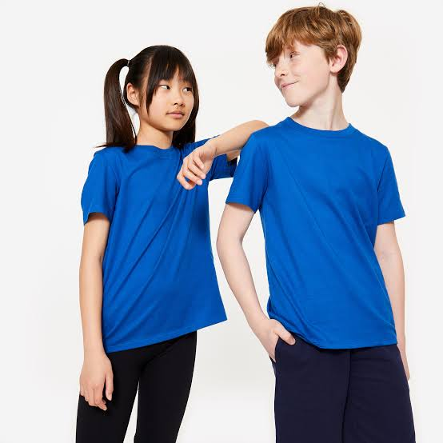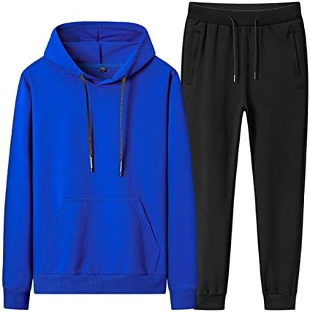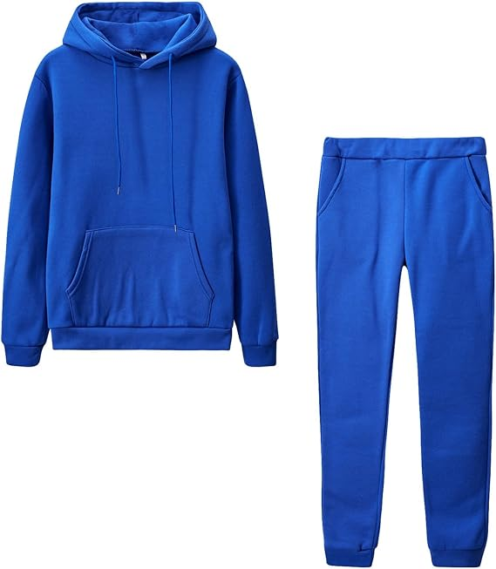
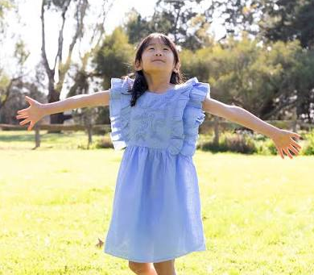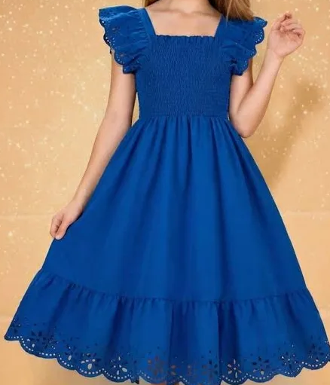
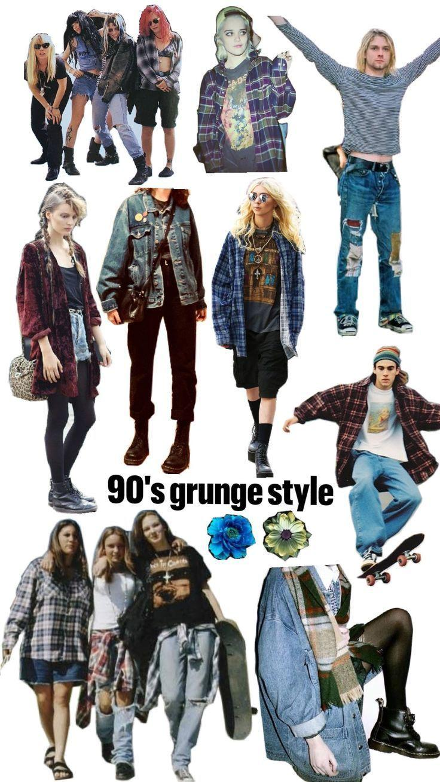
Grades 3C & 3D: Spiderbait – Buy Me a Pony & Calypso – 1996
Costume: 90s Grunge Alternative Rock
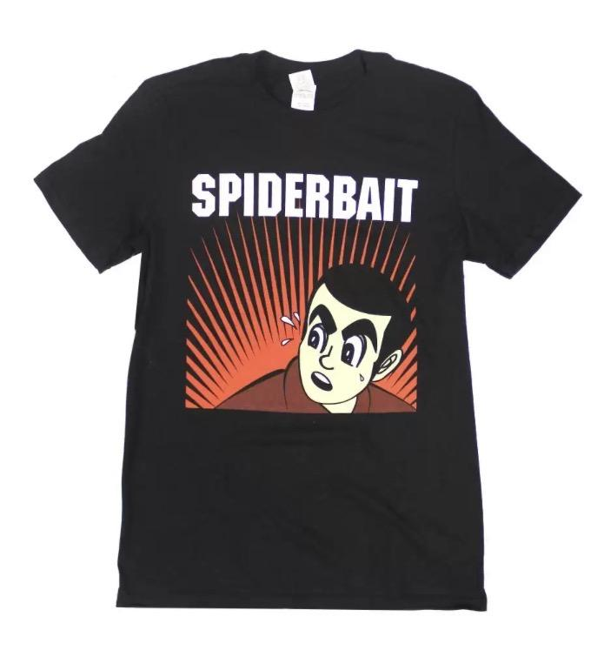
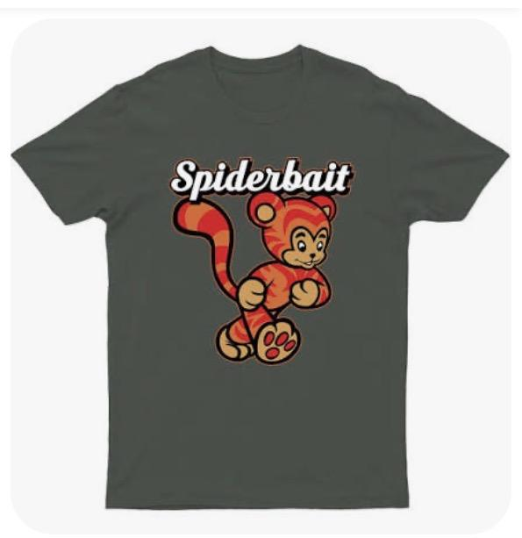
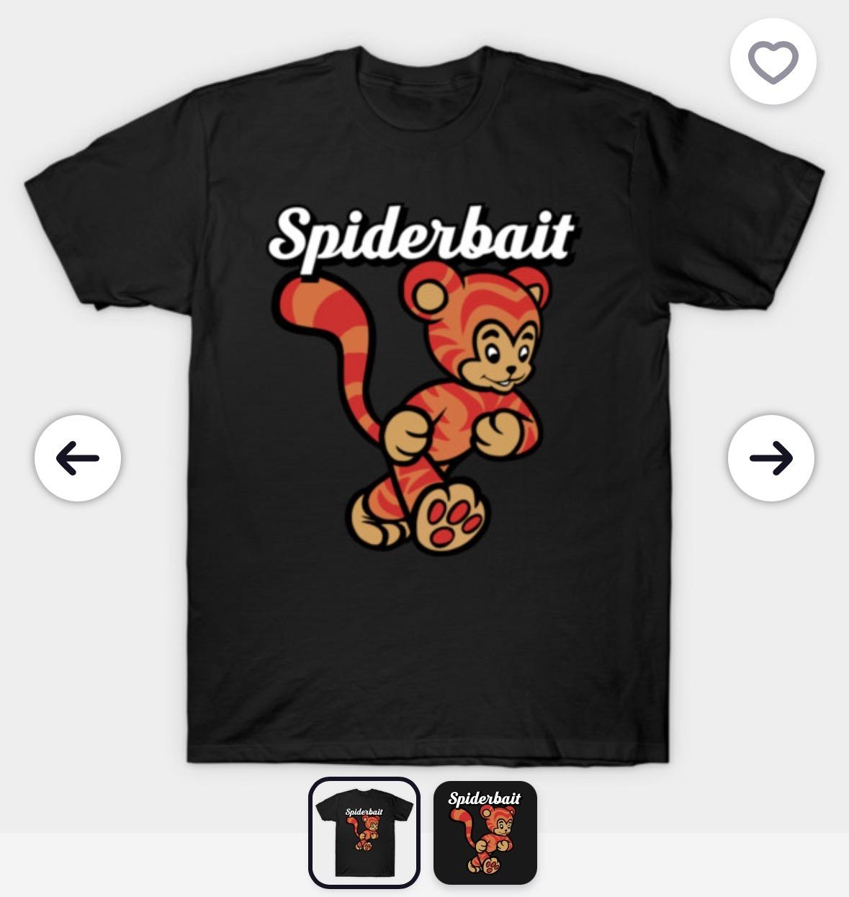

Grade 3 A & B: Fire and the Flood by Vance Joy
Costume: All black clothing and shoes. ***Optional to have red, orange or blue hair spray and other accessories, ie- ribbons, hair clips, shoes***
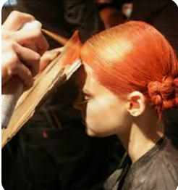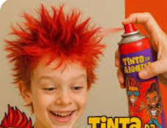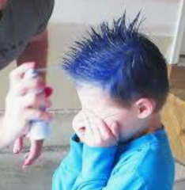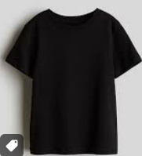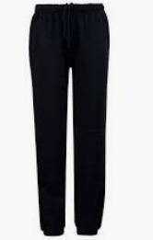

Grades 3E, 4C & 4E: Paul Kelly – From Little Schools, Big Schools Grow
Costume: School student or school teacher
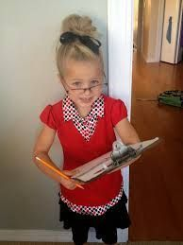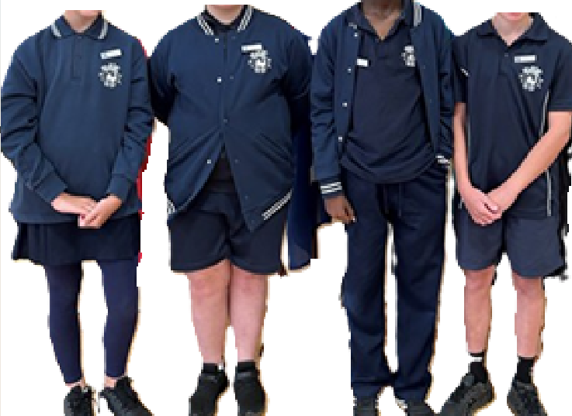

Grades 4A & 4B: Nosebleed Section – Hilltop Hoods

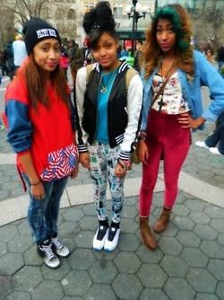
Costume: 2010s Hip Hop style

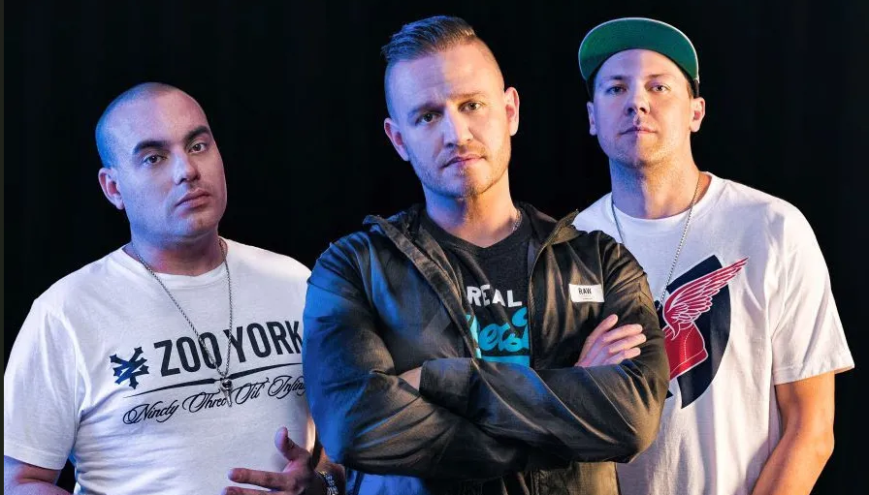

Grade 4D, 5A & 5E: Land Down Under by Men at Work
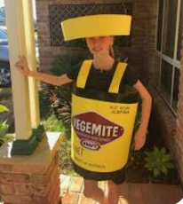
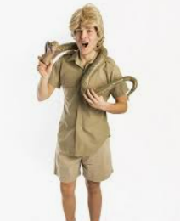
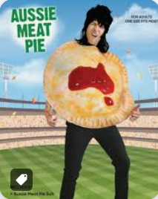
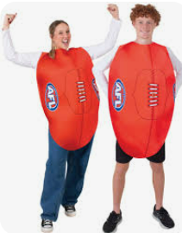
Costume: Australian culture- vegemite, meat pies, footy, cricket, Australian animals, Australian flag, green and gold colours. CREATIVITY welcomed!
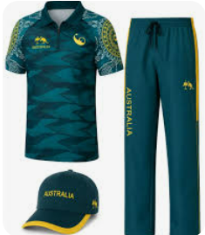
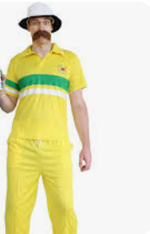
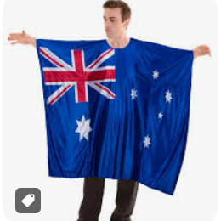
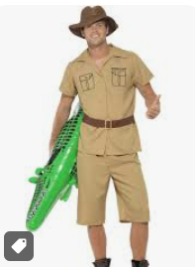

Grades 5B, 5C & 5D: Easybeats – Friday on My Mind - 1966
Costume: 1960s style – Suits (like The Beatles) and Go Go Dancing Dresses/boots
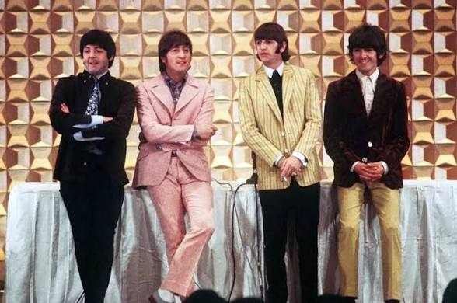

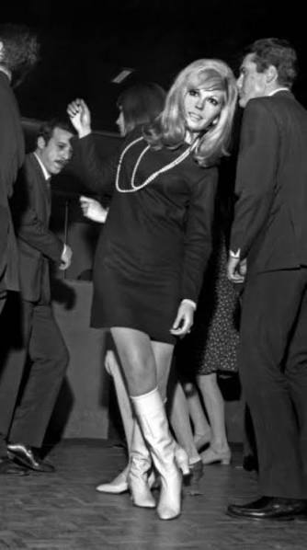
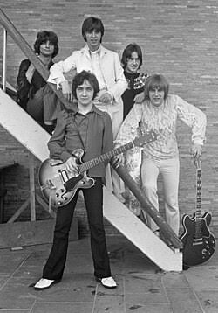

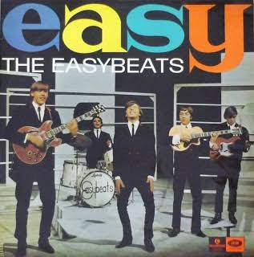

Grades 6A & 6E: Cosby Sweater – Hilltop Hoods
Costume: 2010s Hip Hop style

Grades 6B, 6C & 6D: Forgotten Years – Midnight Oil
Costume: Black Top and Army Green or Khaki Pants or a Nurse
