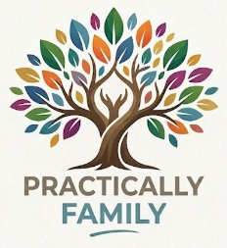
Practical Support • Genuine Compassion • Experienced Care
As a case manager and support worker I aim to provide practical, compassionate, and holistic support for children, adults, and elderly with medical, mental health, or complex needs. This service is designed to offer individuals and their carers reliable, respectful help that makes day-to-day living a little easier.
SERVICES:
- Guidance and support navigating health, community, and support services
- Advocacy
- Goal setting
- General home cleaning, chores, and tasks
- Companionship and wellbeing support
- Carer respite and wellbeing support
- Transport and support with appointments, activities, and essential errands
- Skill development
*Services are flexible and tailored to your individual needs

I understand the challenge of living with and caring for others with additional needs. My goal is to help individuals and families to feel less overwhelmed and more supported in their everyday life.

With a Diploma of Community Services in Case Management, over 10 years of experience as a paramedic, and as a mother of two, I bring both clinical expertise and genuine understanding to the support I provide.

Contact me for a free consultation to discuss how I can help.
Jody (she/her)
0430 972 683
practicallyfamilygroup@gmail.com

